(Approx. 371 words)

Word Preview Pane & Cursor Size - Q&A December 2015
By Mary Phillips, Member ICON Computer Users Group, MO
December 2015 issue, The ICON Newsletter
www.iconusersgroup.org
Mary (at) iconusersgroup.org

Preview Pane

Q1. How do I turn off/on the Preview Pane in MS Word 2013?

A1. If Word opens with the reading pane view by default and you do not want to have to change it each time the following is the way to disable it.

1. In MS Word, click on File –> Options.
2. On the General tab, towards the bottom of the screen look under Start up options for the setting Open e-mail attachments and other uneditable files in reading view.

Uncheck that box.

3. Click OK.

Cursor Size

Q2. How do I increase the thickness of the blinking cursor in MS Word 2013 or Windows 10 WordPad?

A2. The blinking cursor in MS Word or WordPad may be too thin, small or slim for the eyes of many users. But you can always configure or set the thickness of the blinking cursor to a larger size so that the blinking cursor is easier to see.

To increase the size or thickness of the blinking cursor in MS Word:
1. Click on Start button, and then select Control Panel.
2. Select Ease of Access.
3. On Easy of Access window, click Optimize visual display.
Or you go into Ease of Access Center, select Make the computer easier to see.
4. Scroll to the section named Make things on the screen easier to see located at the bottom of the screen.
5. Select a number in the box next to Set the thickness of the blinking cursor option. The default value is 1. The larger the number, the thicker or fatter of the size of the cursor. There is preview available to determine what style fits you best.
6. Click OK
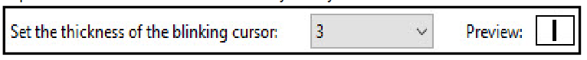
To increase the size or thickness of the blinking cursor in WordPad in Windows 10:
Follow steps 1 and 2 above,
3. In the Ease of Access Window, click on Other options
4. Under the Visual Options, place the mouse pointer to the right on the slider bar and click to adjust the thickness. That ’s it.
